HARLOW ISLAND

Upper Mississippi River System Environmental Management Program

Middle Mississippi River
Miles 140.5-144

Jefferson County, Missouri
St. Louis District

Stone Dike Alteration
Side Channel Creation
Backwater Restoration
Floodplain Restoration
Topography Diversity

RESOURCE PROBLEM:
Harlow Island has accreted to the mainland and no longer provides historic island and side channel habitat that is an important component of the open river ecosystem. Forest habitat is fragmented with low diversity. Non-native grasses have invaded some of the former farm fields. The proposed project would include backwater dredging designed to improve valuable fish and wildlife habitat and dredging to improve seasonal connectivity with the main river channel. Notching of main channel stone dikes would create additional side channel and island habitat. The project would also include planting up to 500 acres of hard mast trees to increase floodplain forest diversity. Installation of spillways at several locations where levees were breached by the flood of 1993 would create temporary wetlands.

PROJECT FEATURES:

- Dredge upper and lower ends of side channel to re-connect to main channel
- Dredge backwaters to improve water quality and aquatic habitat
- Notch main channel dikes
- Plant 500 acres of hard mast trees, utilizing material dredged from backwaters
- Install spillways at levee breaches
- Restore up to 1225 acres of fish and wildlife habitat
- Create 1 mile of side channel habitat

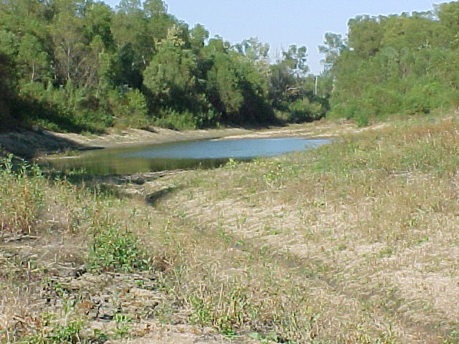

EXPECTED ECOLOGICAL OUTCOMES:
The project would restore 1 mile of backwater habitat, create 1 mile of side channel habitat, restore 500 acres of floodplain forest, and other temporary wetlands and would create additional side channel and island habitat. The project would provide off-channel habitat for the Federally Endangered pallid sturgeon, would improve over-wintering, spawning, and rearing habitat for other fish species, and would improve resting and feeding sites for migratory birds and other wetland species.

ADAPTIVE MANAGEMENT OPPORTUNITIES
This project presents an opportunity for clarifying the effects of backwater and floodplain restoration on fish and wildlife resources, improving our ability to more successfully implement future restoration efforts.
The project also allows the NESP program an early platform to focus on developing a multi-measure reach project vs. individually focused projects.

FINANCIAL DATA:
Detailed estimates for each project component have not been prepared, but the preliminary project cost estimate is under $2.5 million, including planning costs. The project would be 100% federally funded.

STATUS and SCHEDULE:
No baseline monitoring of fish or water quality has been conducted to date.

INFORMATION NEEDS:
At least four seasons of pre-construction fish and water quality data needs to be collected for comparison to post-construction data.

Several years of post-construction fish and water quality monitoring would need to be conducted.

Survival of hard mast trees would need to be monitored.

Bathymetric survey work will need to be conducted pre and post construction.

